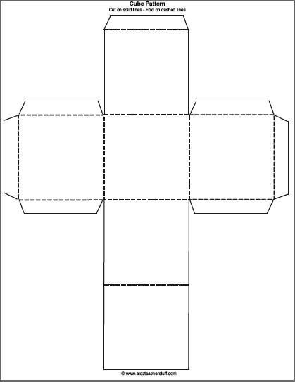

Essential vocab can ensure ___ students are ___ to info to help ____ important ____ content.

How many high frequency “academic tool kit” words are there across the subjects?

According to Kate Kinsella, vocabulary knowledge is the single best predictor of …

What is the average number of terms students are expected to learn in their History classes?

What does Ruby Payne have to say about poverty and education?

According to Marzano, what are the 6 steps of vocabulary instruction?